
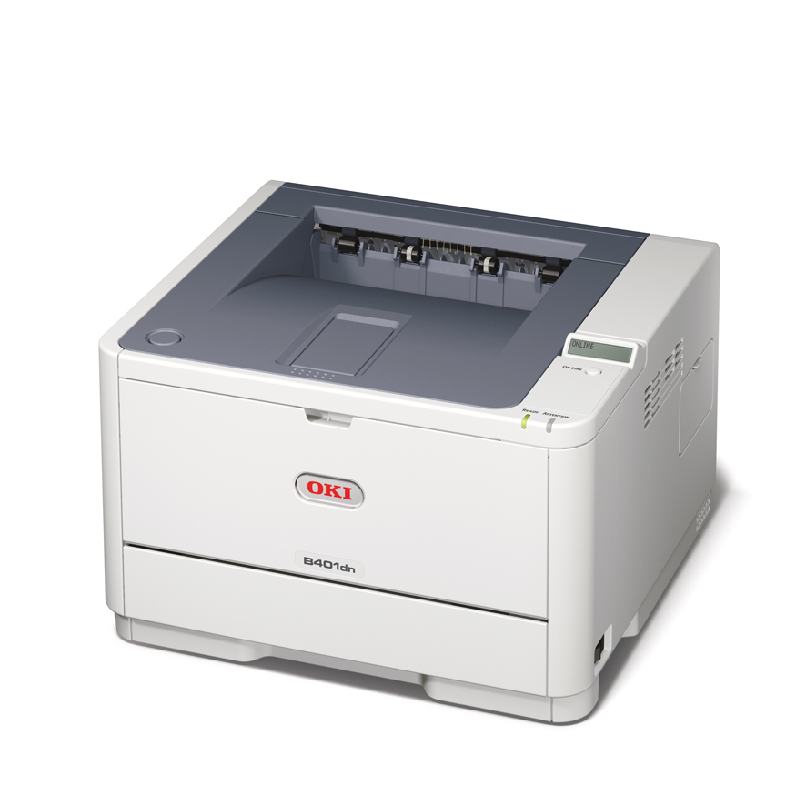
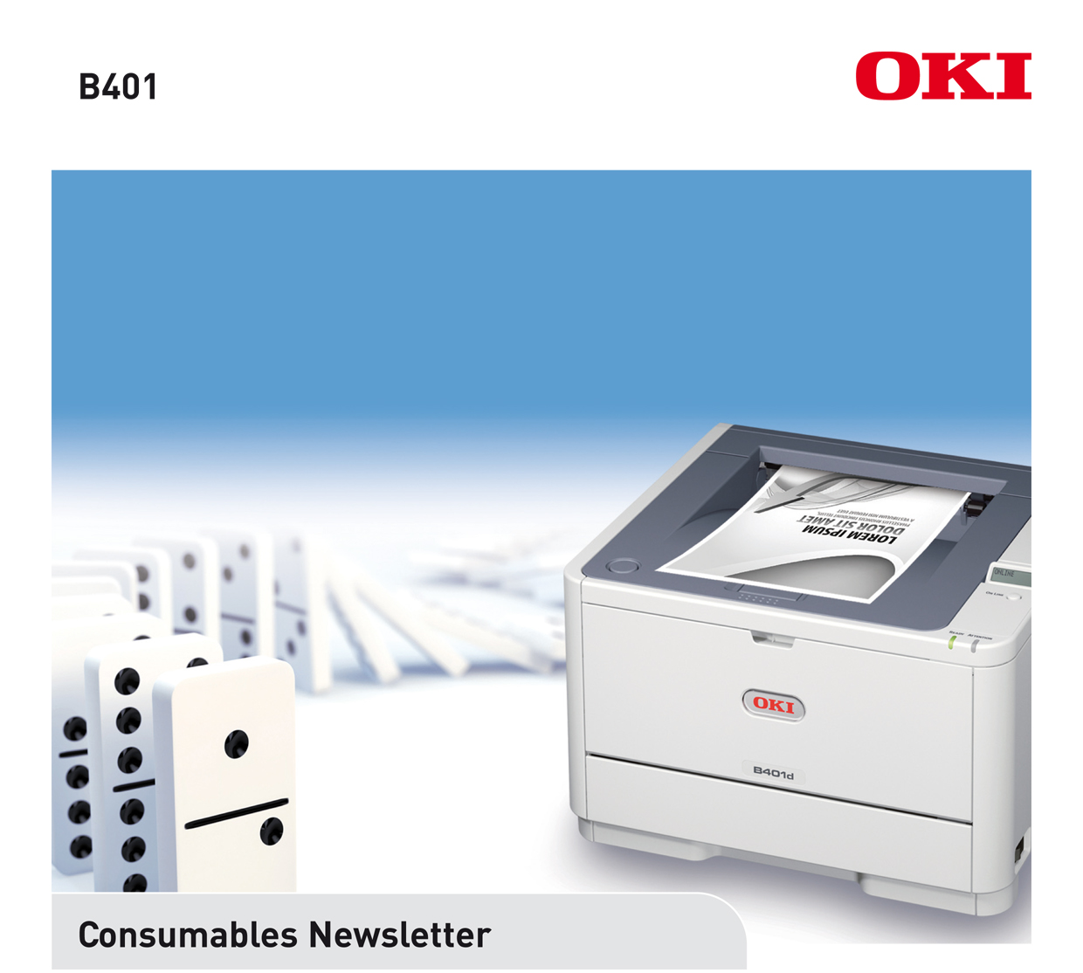
DATE: March 2012
ISSUED BY: Jane Mannering (jane.mannering@okieurope.com)
SUBJECT: B401 Consumables

A4 mono | 
Range of media handling | 
Print speed of up to 29ppm | 
Time to first print less than 5.5 seconds | 
1 to 5 users | 

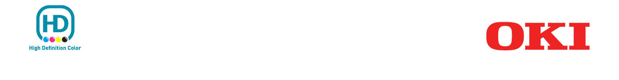
© 2012 Oki Europe Ltd. Version 1.0 3.2012.
OKI EUROPE LTD.
Blays House, Wick Road
Egham TW20 0HJ
United Kingdom
T +44(0) 20 8219 2190
F +44(0) 20 8219 2199
WWW.OKIPRINTINGSOLUTIONS.COM

B401
Product | Standard Capacity Toner | High Capacity Toner | Image Drum
Available From | April 2012 | April 2012 | April 2012
Order Code | 44992401 | 44992402 | 44574307
EAN Code | 5031713055365 | 5031713055389 | 5031713054757
Pallet Quantity | 330 | 330 | 36
Minimum Order Quantity | 1 | 1 | 1
Yield | 1,500 pages * | 2,500 pages * | 25,000 pages **
New or Existing Product | new | new | new
Compatible With | B401/MB441/MB451 | B401/MB441/MB451 | B401/MB441/MB451
Weight Kg  (box & consumable) | 0.400 | 0.400 | 1.600
Dimensions in mm of packaging w x d x h | 300 x 80 x 93 | 300 x 80 x 93 | 391 x 258 x 236

* Yield compliant with ISO/IEC 19752
** Average life A4 based on a typical office environment
† For the protection of your product, and in order to ensure that you benefit from its full functionality, this
model has been designed to operate only with genuine Oki Printing Solutions toner cartridges. These can
be identified by the Oki trademark. Any other toner cartridge may not operate at all, even if it is described
as “compatible”, and if it does work, your product's performance and print quality may be degraded.

